Project Design Phase

Problem – Solution Fit Template
Date: 02 November 2025
Team ID: NM2025TMID03190
Project Name: Laptop Request Catalog Item
Team Members: Indra & Buvana
Maximum Marks: 2 Marks

Problem – Solution Fit Template:
The Problem–Solution Fit represents the alignment between the identified problem of the customer and the solution designed to address it effectively. It ensures that the Laptop Request Catalog Item project accurately resolves the pain points experienced by employees and IT teams. This concept helps developers and stakeholders validate that the proposed solution fulfills user needs and improves existing workflows within the ServiceNow platform.

Purpose:
❑ Solve the problem of delayed and inefficient laptop requests by offering a centralized, automated solution.
❑ Ensure faster adoption of the ServiceNow Laptop Request Catalog Item through a user-friendly and transparent workflow.
❑ Improve communication and coordination between employees, managers, and IT staff through automated status updates.
❑ Enhance operational efficiency by minimizing manual errors and reducing processing time.
❑ Understand user requirements to create a scalable and reliable system that simplifies asset management.

Template:
The project "Laptop Request Catalog Item" addresses a key challenge faced by employees in organizations—the lack of a structured and transparent laptop request process. Traditionally, laptop requests are handled through manual emails or offline communication, resulting in delays and confusion. This project provides a ServiceNow-based digital catalog item that automates the request, approval, and fulfillment process.

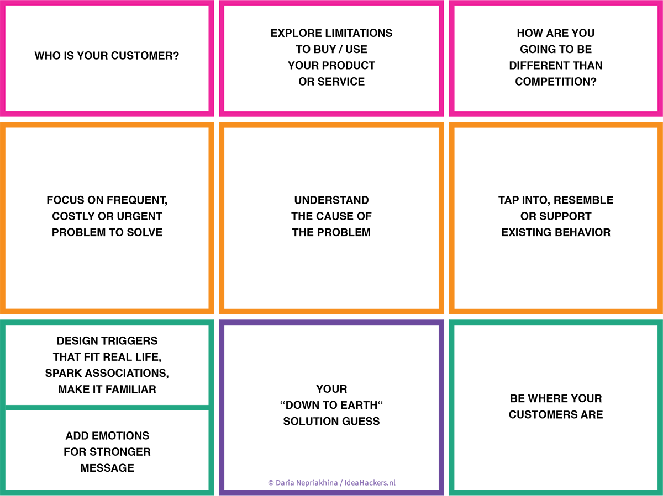
By integrating automated approval workflows, inventory tracking, and email notifications, the system ensures that requests are processed quickly and accurately. Employees can view request statuses in real-time, and IT staff can efficiently manage laptop distribution. This improves user satisfaction, saves administrative time, and strengthens accountability across departments. The successful implementation of this solution establishes a foundation for digitized, efficient asset management within enterprise environments.

